August 2023

Dear [insert name of MP/Senator here]

We write to you today to highlight the pressing need for funding to develop a comprehensive diagnostic framework and treatment pathway for Tourette Syndrome (TS). As elected representatives, we urge you to consider allocating the necessary resources to support this critical initiative, which will greatly improve the lives of individuals and families affected by TS.

Tourette Syndrome is a complex neurological disorder characterised by involuntary movements and vocalisations called tics. It affects people of all ages and often begins in childhood. Individuals with TS face unique challenges in their daily lives, including social stigma, difficulties in education and employment, and limited access to appropriate healthcare services.
Quality of Life Score – Children and Adolescents with TS:
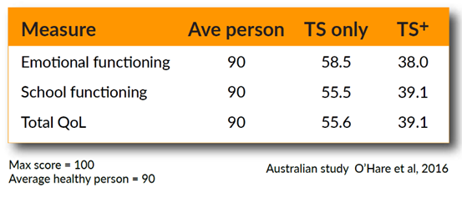
TS+ refers to people with TS and other comorbidities.
Despite its prevalence, TS remains widely misunderstood, leading to delayed or inaccurate diagnoses and inadequate treatment options. It is essential to address these gaps by establishing a standardised diagnostic framework and treatment pathway for TS. This comprehensive approach will not only facilitate early identification and intervention but also ensure that individuals with TS receive the appropriate support and care they need.

By allocating funding for the creation of a diagnostic framework and treatment pathway for TS, several significant benefits can be realised:
Accurate Diagnosis: A standardised diagnostic framework will enable healthcare professionals to recognise and diagnose TS more effectively. This will reduce misdiagnoses and ensure that individuals with TS receive timely and appropriate interventions.
Early Intervention: Early identification and intervention are crucial for individuals with TS. With a clear diagnostic framework, children and adults with TS can access support services and treatments at an earlier stage, optimising their chances for improved outcomes.
Tailored Treatment: A well-defined treatment pathway will guide healthcare professionals in delivering evidence-based interventions and therapies specific to TS. This will enhance treatment efficacy, quality of life, and overall well-being for individuals with TS.
Specialised Care: Funding the creation of a treatment pathway will support the development of specialised TS clinics and services. These dedicated resources will provide comprehensive care, including access to multidisciplinary teams of healthcare professionals with expertise in TS management.
Research Advancement: Investment in a diagnostic framework and treatment pathway will foster research collaborations and initiatives focused on TS. This will lead to a better understanding of the condition, advancements in treatment options, and improved outcomes for individuals with TS.

We urge you to recognise the urgency of funding the creation of a diagnostic framework and treatment pathway for Tourette Syndrome. By providing the necessary resources, you can make a profound impact on the lives of individuals and families affected by TS, ensuring they receive the support, care, and understanding they deserve.

We also urgently request that you to demonstrate your commitment to promoting accessible and effective healthcare for all individuals with TS, by supporting Tourette Syndrome Association of Australia in their pursuit of funding the creation of this essential diagnostic framework and treatment pathway.

Thank you for your attention to this matter. We look forward to your support in advancing the diagnosis and treatment of Tourette Syndrome.

Sincerely,
[Your Name]

